Supply Chain Management (SCM) — NPTEL
Week 12 · Session 4: Blockchain + Industry 4.0 Technology × SC Function Mapping & IoT Case Studies
1. Recap & Session Scope
- Sessions 1–3 (Week 12): Digitization pyramid, Industry 4.0 intro, 9 pillars in detail (IoT, Cloud, H/V Integration, Cyber Security, Big Data, Simulation, AR, Robots, Additive Manufacturing)
- This session: Blockchain (definition, 3-step process, 5 network types) + I4.0 Technology × SC Function mapping + IoT case studies across 5 SC functions

2. Blockchain — Definition & Role
- Definition: a distributed ledger technology where secure and transparent recording of transactions and data occurs across a network of computers
- Two defining properties: Secure (tamper-proof, cryptographically protected) AND Transparent (visible to all authorized network members) — both simultaneously
- How it works: transactions are gathered into blocks and recorded as a chronological chain — hence 'blockchain'
- In Industry 4.0: blockchain is an enabler of digitalization — some frameworks include it as a pillar, others treat it as an enabler. Either way, it is critical for SC transparency and traceability.

Blockchain in SC — What it Enables
- Track suppliers, vendors, material sources, and pricing across the SC
- Secure, tamper-proof record keeping of all transactions and product movements
- Builds trust between SC partners — no single party can alter the shared history
- Applications: finance, supply chain, healthcare, voting, and any domain with multi-party transactions

★ Blockchain is NOT just a database. It is a distributed, tamper-evident record that no single party controls — this makes it uniquely suited for multi-partner SC transactions.

3. How Blockchain Works — 3-Step Process
1 | Transaction Recording | When a transaction occurs between network partners, all details are captured as a block of data  Details recorded: who did it, when, where, for what purpose, how much — full transaction metadata  The block = a complete, structured record of one transaction
2 | Blockchain Formation | Multiple blocks are linked together in chronological order → forming a chain  Before a new block is added, it must be VALIDATED by the network via a consensus mechanism  Consensus ensures no single party can add fraudulent data — all network members must agree
3 | Immutability | Each new block also re-verifies the previous block when being added → strengthens the chain  Result: data in the blockchain is tamper-evident — any change is detectable  Immutable = cannot be altered retroactively by any malicious actor → trusted ledger for all members

- Consensus mechanism: before any block is added, all network members must agree it is valid — prevents any single fraudulent entry
- Cryptographic linking: each block contains a cryptographic reference to the previous block → changing one block would break the chain → instantly detectable

★ Transaction → Block → Validation (consensus) → Added to Chain → Immutable. This 3-step cycle is the core of how blockchain builds trust without a central authority.

4. Types of Blockchain Networks
Network Type | Who Controls / Joins | Speed | Security | Typical Use
Public | Anyone — open access, fully decentralized | Slower | More secure (decentralised) | Cryptocurrency, decentralised apps
Private | Single org governs and controls who participates | Faster | High (limited access) | Internal process streamlining, efficiency improvement
Permissioned | Participants need approval from a governing body to join | Fast | High | Where high control over network membership is required
Consortium | Group of pre-selected orgs jointly govern the network | Fast | High | Inter-org collaboration on a shared project, no single governing body
Hybrid | Combination of two or more of the above — chosen based on business need | Varies | Varies | Complex enterprise environments needing flexibility

Selection Logic
- Need openness + decentralization? → Public (e.g., cryptocurrency)
- Single org, internal processes? → Private (faster, more controlled)
- Need membership approval? → Permissioned
- Multiple orgs sharing a project? → Consortium (no single governing org)
- Complex mix of requirements? → Hybrid

5. Industry 4.0 Technologies × SC Functions — Application Matrix
- Different I4.0 technologies are applicable to different SC functions. The matrix below shows where each technology adds value:

Technology | Planning & Forecasting | Sourcing & Procurement | Production & Mfg | Inventory Mgmt | Distribution & Logistics | Customer Service
AI / ML | ✓ | ✓ | ✓ | ✓ | ✓ | ✓
IoT | ✓ | ✓ | ✓ | ✓ | ✓ | —
Cloud Computing | ✓ | ✓ | ✓ | ✓ | ✓ | ✓
Big Data Analytics | ✓ | ✓ | ✓ | ✓ | ✓ | ✓
Simulation / Dig. Twin | ✓ | ✓ | ✓ | ✓ | ✓ | —
Blockchain | ✓ | ✓ | ✓ | ✓ | ✓ | —
Autonomous Robots | — | — | ✓ | ✓ | ✓ | —
AR | — | — | ✓ | ✓ | ✓ | —
Additive Manufacturing | — | — | ✓ | — | — | —

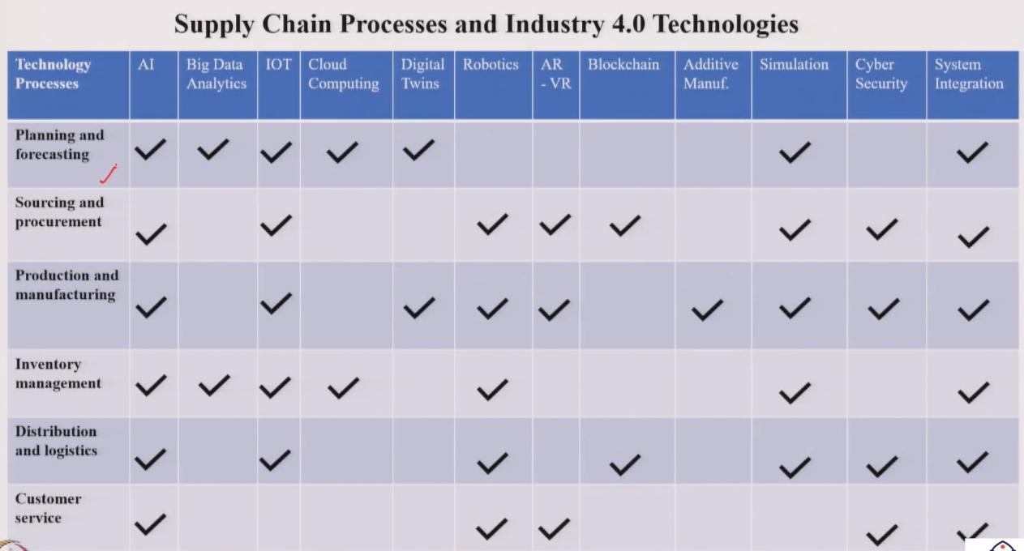
- Key observations: AI/ML and Cloud/Big Data are applicable across all 6 SC functions — most horizontal reach. Autonomous Robots and Additive Manufacturing are more specific to production/logistics/inventory.
- Important caveat: this matrix shows indicative applicability — actual fit depends on specific business context and process requirements

6. IoT — Case Studies Across 5 SC Functions
- Note: all company names are hypothetical — cases are developed for learning purposes to illustrate realistic IoT applications

SC Function | Company & Industry | Challenge → IoT Solution → Outcome
Planning & Forecasting | Omega Foods (Grocery Distributor) | Challenge: poor demand forecasting for perishables → spoilage or backorders. Historical sales data alone insufficient.  IoT solution: smart sensors tracking temperature + stock levels across warehouses and delivery trucks in real time  Outcome: real-time data → predict consumption rate + shelf life → adjust delivery schedules → targeted promotions at high-demand locations → reduced spoilage
Sourcing & Procurement | Acme Pharmaceuticals (Drug Manufacturer) | Challenge: frequent stockouts and operational delays due to manual inventory tracking methods  IoT solution: smart sensors embedded in shelves and material racks → real-time stock data → auto-triggers purchase orders when inventory falls below threshold  Outcome: stockouts eliminated, procurement cycle optimized via smart contracts, overall cost reduced
Production & Manufacturing | Newton Instruments (Violin Maker) | Challenge: maintaining optimal humidity levels in workshop critical for violin quality — fluctuations cause cracks and warping → production delays and waste  IoT solution: humidity sensors embedded in workshop → smart vents auto-adjust airflow to maintain consistent regulated environment  Outcome: consistently controlled production environment → increased production yield → waste reduced → instrument quality preserved
Inventory Management | Vendor Guitars (Instrument Maker) | Challenge: instruments lost during shipping → impacts customer service and operational efficiency  IoT solution: location tracking sensors embedded in guitar cases → real-time visibility of each guitar throughout the entire SC  Outcome: lost instruments eliminated, deliveries expedited, logistics optimized, customer satisfaction improved, brand reputation strengthened
Distribution & Logistics | Best Pharmaceuticals (Drug Distributor) | Challenge: spoilage of temperature-sensitive medications and delays due to inconsistent temperature conditions during transport  IoT solution: cold chain monitoring — sensors in shipping containers track real-time temperature and humidity throughout transit  Outcome: complete shipment condition visibility → routes and storage practices optimized → medication quality preserved → partnership quality improved → global healthcare access improved

Cross-Case Observations
- Common IoT pattern: real-time sensor data → analytics engine → automated action or optimized decision
- IoT benefits seen across cases: reduced waste, eliminated stockouts, improved customer service, quality preservation, cost reduction
- In all 5 cases, the IoT implementation either prevents a problem (proactive) or enables faster recovery (reactive)
- Cold chain (Best Pharmaceuticals) shows how IoT enables both monitoring AND decision optimization simultaneously

★ IoT in SC = sense → transmit → analyze → act. Each case study demonstrates a different 'sense' objective: temperature, stock level, humidity, location, or shipment condition.

Session Summary
- Blockchain: distributed ledger — secure + transparent. 3 steps: Transaction Recording → Chain Formation (consensus) → Immutability
- 5 network types: Public (open, decentralized) | Private (single org, fast) | Permissioned (approval-based) | Consortium (multi-org, no single authority) | Hybrid (mix)
- SC application: track suppliers/vendors/materials, tamper-proof records, builds partner trust
- I4.0 × SC matrix: AI/ML + Cloud + Big Data → all 6 functions. IoT → 5 functions (excl. customer service). Robots + AR → production, inventory, logistics. Additive → production only.
- 5 IoT case studies: Omega Foods (forecasting) | Acme Pharma (procurement) | Newton Instruments (manufacturing) | Vendor Guitars (inventory) | Best Pharma (distribution/cold chain)

★ Exam Tip: Blockchain 3 steps: (1) Transaction Recording — capture all details as a block, (2) Blockchain Formation — link blocks chronologically via consensus mechanism, (3) Immutability — each addition re-verifies previous blocks, making data tamper-evident.
★ Exam Tip: 5 blockchain network types: Public (open, slow, decentralized — crypto), Private (single org, fast — internal processes), Permissioned (approval required), Consortium (multi-org, shared project), Hybrid (combination).
★ Exam Tip: Consensus mechanism = all network members must validate and agree before a block is added. This prevents any single party from adding fraudulent data — the core security mechanism of blockchain.
★ Exam Tip: IoT case pattern: sense a condition (temperature, stock, humidity, location) → transmit real-time data → analyze → act (auto-adjust, trigger order, optimise route). Applicable to planning, sourcing, production, inventory, distribution.

